13_Discover_Trended Performance (Vlookup)
Report Views
Standard View
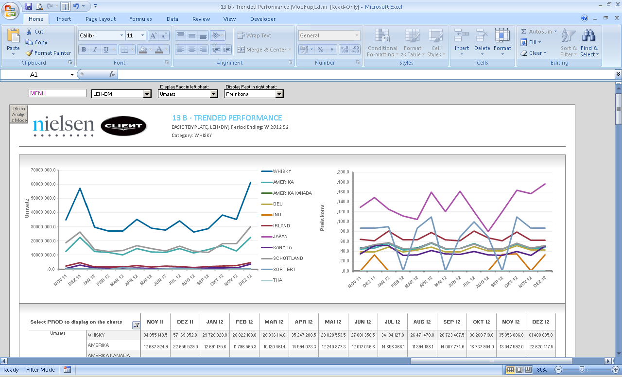

Standard View
Guidelines
Template Name | 13_Discover_Trended Performance (Vlookup)
View Name | Basic Template
Methodology | VLOOKUP
Default Dimension Order in WSP | Page Bar
Default Dimension Order in WSP | Columns | 1 Dimensions | Periods
Default Dimension Order in WSP | Rows | 3 Dimension | Markets, Facts, Products
Change dimension | - If a different layout is needed, please select a different template  - The dimensions can be swapped, except for the Periods dimension. Any other dimension can be swapped freely following this logic:  - First Position in data set Rows appears as Dimension in Drop Down  - Second and third Position in data set Rows are aligned with Dimensions in Template Row  - Second Position in data set Rows appears as Row 1 in Template  - Third Position in data set Rows appears as Row 2 in Template  - Dimension in data set Column (must be “Periods”) appears as Dimension in Template Column
Data Selection Guidelines | Facts | - Limited to 100 items
Data Selection Guidelines | Products | - Limited to 100 items  - Product selection always starts with 100% Product (Total Category) followed by the selection of the other items to be shown in the template
Data Selection Guidelines | Markets | - Limited to 100 items
Data Selection Guidelines | Periods | - Limited to 100 items
Data Selection Guidelines | NOTE: For the dimension in the Page Bar, the maximum number of items is 100.  IMPORTANT:  - If report performance is poor, i.e., file opening and changing drop down selections take longer than several seconds (not acceptable by end user), remove any unused data rows from each Output Sheet, to improve user experience.  *Poor performance can be observed mostly in reports with multiple Output Sheets.  Example Scenario:  *Before removing rows, ensure you do not remove any important part of report configuration area.  RATIONALE: Individual cells in each row contain formulas, which need to be re-calculated every time a report is opened or drop down selection is changed. These additional operations, which run in the background, can negatively impact report performance, e.g., in a template with 40 formulas per row and 390 unused rows, the number of unnecessary operations is ~15600.
  Description | # Rows
  Default number of data rows handled by template | 500
  Number of items in rows (current report selection) | 60
  Buffer for any fluctuations in rows (deletions/additions of items in the future) | 50
  Unused number of data rows to be removed | 500-(60+50) = 390
To create a new report from this template | - Use the report in Discover related to this report.  - Welcome Sheet – Insert all the needed information on the Configuration Area  - Output Sheet – When more columns must be added, always copy/paste from existing ones.  - Add or delete the needed columns to accommodate the retrieved information  - Never delete column outside the print Area.  - Depending on the number of periods and facts, the table formatting will have to be adjusted  - To make formatting easier, the existing formats can be copied  - When the new source Sheet using the add-in is created, you have to run the following Macro: InsertColumns  - Add a Freeze Panes if needed (In case all the columns can’t be shown in the screen or long list of rows).

